Meet Your Learning Resource Team

Abbie Luoma- Director of Learning Resources
abbie.luoma@saintleo.edu | (352)-588-8674
UNDERGRADUATE: (HCA) Healthcare Administration ·(NUR) Nursing · (SWK) Social Work
GRADUATE: (SWK) Social Work (MSW)

Jessica Moreira
jessica.moreira@saintleo.edu | (352)-588-8569

UNDERGRADUATE: (ANT) Anthropology · (ART) Art/Art History · (BIO) Biology · (CHE) Chemistry · (CRM) Criminal Justice · (EDU) Education · (EME) Emergency Management · (ENG) English · (FAS) Fine Arts · (GEO) Geography · (GER) German · (HON) Honors · (HTY) History · (HUM) Humanities · (IDS) Interdisciplinary Inquiry in the Arts · (LBS) Liberal Studies · (MHU) Medical Humanities · (MUS) Music · (NUR) Nursing · (PED) Physical Education · (PHI) Philosophy · (PHY) Physics · (POL) Political Science · (PSY) Psychology · (REL) Religion · (RUS) Russian · (SCI) Science · (SLU) University Studies · (SOC) Sociology · (SPA) Spanish · (SPH) Speech · (SSC) Social Sciences · (VTS) Veterans' Studies
GRADUATE: (CRJ) Criminal Justice · (CRW) Creative Writing · (DCJ) Doctor of Criminal Justice · (EDD) Doctor of Education · (EDU) Education · (PSY) Psychology · (THY) Theology

Asierleigh Richards
asierleigh.richard@saintleo.edu | (352)-588-8342
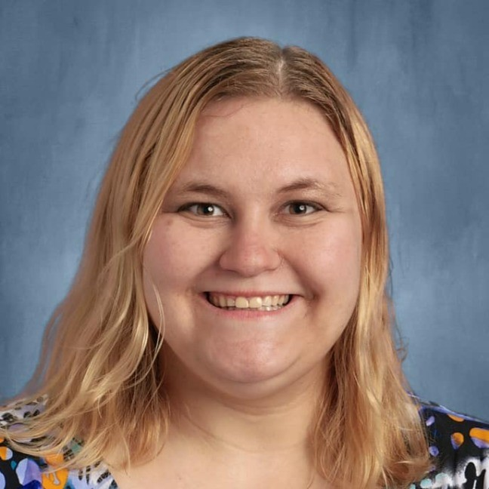
UNDERGRADUATE: (ACC) Accounting · (CMM) Communication Management · (COM) Computer Science and Information Management · (ECO) Economics · (GBA) General Business Administration · (HCM) Health Care Management · (HRA) Human Resources Management · (IHT) International Tourism and Hospitality Management · (MAT) Mathematics · (MGT) Management · (MKT) Marketing · (MMM) Multimedia Management · (RAI) Robotics
GRADUATE: (ACC) Accounting · (COM) Information Security Management · (DBA) Doctor of Business Administration · (FIN) Finance · (HCM) Health Care Management · (HRA) Human Resource Management · (MBA) Business Administration · (MKT) Marketing · (PRM) Project Management · (SCM) Supply Chain Management · (SE) Software Engineering · (SPB) Sport Business

