Department of Learning Resources | 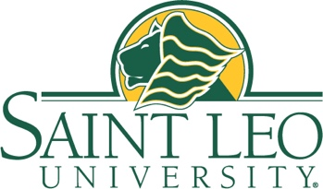 | University Campus  33701 County Road 52  St. Leo, FL 33574  faculty.textbooks@saintleo.edu
Course Materials Connection FAQ
The Course Materials Connection program provides students with streamlined, affordable access to their required course materials through our bookstore partner, BibliU. This FAQ is designed to help faculty understand how the program works for their students and contains answers to commonly asked questions.
Are my students automatically enrolled in Course Materials Connection for my course?
Yes. If your course participates in the Equitable Access program, your students will automatically receive access to the required materials. They do have the option to opt out by the add/drop deadline. If they opt out, they’ll be responsible for sourcing all required materials independently through the campus store website or another retailer. Opting out applies to all of their enrolled courses for the term.
Can my students opt out of the program?
Yes. Your students can opt out if they prefer not to use the digital materials. The opt-out deadline will be shared with them in a welcome email from BibliU and may also appear in their LMS. If they opt out by the deadline, their access will be removed, and the charge will be reversed. They can opt out and opt in as many times as they would like before the opt-out deadline.
How do my students opt out?
Your students can opt out using the link provided in the BibliU welcome email, through a link in their LMS (e.g., D2L, Canvas, etc.), or by going directly to the BibliU app.
Can my students opt back in after opting out?
Yes, they can opt back in any time before the deadline using the same methods: the opt-out link, or the LMS.
If my students don’t use the materials, will they still be charged?
Yes. All students enrolled in a participating course are automatically granted access and billed unless they opt out by the deadline, even if they don’t use the materials.

