

Call for Proposals

2025 Saint Leo University Interdisciplinary Conference on *POWER*

When: Saturday, April 5, 2025, 9:00 AM – 5:00 PM

Where: Saint Leo University

The 2025 Saint Leo University Interdisciplinary Conference facilitates scholarly debates across disciplines on the theme of *POWER*. This will be an interactive in-person conference with engagement between presenters and attendees in the style of a symposium. We welcome proposals for Individual Papers and Group Proposals from faculty members, adjunct instructors, and graduate students from all disciplines and neighboring institutions.

Description:

The word “power” can immediately evoke images of social agents, political actors, or economic structures, but these are far from its only possible meanings, and arguably not even its most important ones. Power has an exceptionally wide semantic field. The basic unifying concept seems to be the abstract notion of untapped or unspecified capacity or ability. Since virtually anything conceivable has the potential to be of consequence in at least some way, power can denote innumerably different and extraordinarily diverse things. Qualitatively different, these many disparate notions of power all share a quantitative aspect. In a supreme, if not also ironic, act of self-exemplification, the word power seems to possess almost limitless potential. Indeed, *potentia* means power in Latin. The 2025 Saint Leo University Interdisciplinary Conference will explore the array of meanings of power across academic disciplines.

Topic Examples:

The “possibilities” offered here are not exhaustive, and creative thinking in other directions is encouraged. Examples of topics are included here to help stimulate thinking related to the many ways to conceptualize the concept of Power:

* Economists considering the power of incentives and spending power
* Political scientists exploring how the quest for new power sources shapes political relationships and diplomacy
* Mathematicians discussing the exponents as powers
* Natural scientists explaining nature’s “four fundamental forces” or “potential energy” in Newtonian physics
* Philosophers expounding upon “causal powers” in ontology
* Theologians navigating between the idea of spiritual power as the antithesis of our conventional notions of power on the one hand, and divine perfection as the superlative of conventional notions of power (omnipotence) on the other
* Scholars of literature discoursing upon the power of the written word to move us emotionally, move us to act, and even change the world
* Biologists exploring power in relationship to a particular biological process, like photosynthesis, and the mechanisms powering the growth of cells and organisms
* Computer scientists reporting on how scientists are investigating the power of light to create quantum computers, and to develop powerful tools for the encryption of data
* Criminologists considering how media framing of criminal justice issues affect the public’s perception of police power and accountability
* Criminologists exploring how power dynamics between law enforcement and the community shape perceptions of legitimacy, trust and fairness
* Intellectuals questioning what mechanisms of accountability are needed to prevent abuse of power

Creative collaborative contributions are also encouraged. For instance:

* Science and popular culture could meet in a consideration of how light/energy/radiation can create superpowers in the popular imagination (Superman, Spiderman, the Hulk)
* Science and religion could explore the connections between how light/energy is fundamental and the biblical creation account beginning with “Let there be light!”
* The role of divine power in the problem of evil and suffering appears in multiple disciplines
* Psychologists and sports experts could join to examine power in sports psychology
* Multiple disciplines could explore artificial power, the role that humans play in it, and assessments of it positive and negative effects, e.g., Is humanity’s harnessing of nature’s power a boon for humanity or will it ultimately end with Frankenstein?

Additional possibilities would include, but are not limited to:

* Legal powers and jurisprudence
* The power of the performing arts (music, film, visual art, dance, etc.)
* Power lunches, power naps, and/or power skills
* Willpower
* Power in religion (to influence individual and groups, cults, religious leaders, miracles and magic, etc.)
* The power of love
* The costs and benefits of a certain type of power
* Powersports

Proposal Format:

1. Title of work (interesting and jargon-free)
2. Author(s) names, professional titles, and email contact information
3. Abstract: up to 200 words, with brief overview of the aims and length of the presentation as well as a description of how the work addresses the conference theme

* Please discuss any visuals that will be used to support or enhance proposed text-based presentations.

Details for Presenters and Attendees:

This conference is free for Saint Leo-affiliated participants.

Conference registration for non-Saint Leo University affiliated attendees will be $20.00 (includes refreshments) payable upon arrival at the conference.

Refreshments will be provided. The cost of lunch is not included in the conference registration but lunch will be available at the Saint Leo University Cafeteria at a discounted price.

Deadline to submit proposals: Monday, December 16, 2024

Deadline to register for conference attendance: Friday, April 4, 2025, 5:00 pm

To submit a conference proposal, please complete this form using the link or the QR code:

<https://forms.office.com/r/Y2SJDiTL5f>

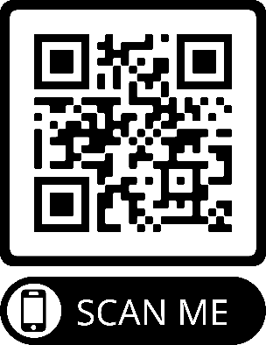

# (PROPOSAL SUBMISSION QR CODE)

To register for the conference, or volunteer as Chair of a Session, please complete this form using the link or the QR code:

<https://forms.office.com/r/m5wMhXbKxU>

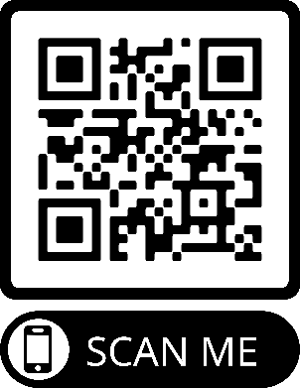

# (REGISTRATION QR CODE)

For further information on the 2025 Saint Leo University Interdisciplinary Conference, please e-mail: CASAS@saintleo.edu.